Technical Notes for the Raytracing of Toroidal Surfaces

Table of Contents
Technical Notes for the Raytracing of Toroidal Surfaces 1
Introduction 2
Toroidal Surface Description 3
Range of x & y for Solutions at Real Numbers 5
Normal Vector of Toroidal Surface 6
Intersection of a Ray and a Torus 8
Special Case: Cylinder Lens 10
Cylinder-Line Intersection 10
Parametrical Toroidal Surface Description 12
Practical Example with MATLAB 12
Attachement 13

Introduction
In geometry, a torus is a surface of revolution generated by revolving a circle in three-dimensional space about an axis that is coplanar with the circle.
In optics, a toroidal surface is described with the circle radius $r_{x}$ and the distance $R_{y}$ to the $y$-axis, known as the radius of rotation.
According to ZEMAX, the curve in the Y-Z plane is defined by
$$z_{x=0}=\frac{\frac{1}{r_{x}}y^{2}}{1+\sqrt{1-\left(1+κ\right)\frac{1}{r_{x}^{2}}y^{2} }}+α_{1}y^{2}+α_{2}y^{4}+… ,$$ | (1)
where $κ$ is the conic constant with respect to the $y$-direction. However, the complete three-dimensional formulation is not given in [Zemax11]. The toroidal surface is shown in Figure 1, whereby the blue curve indicates the curve given by equation (1).
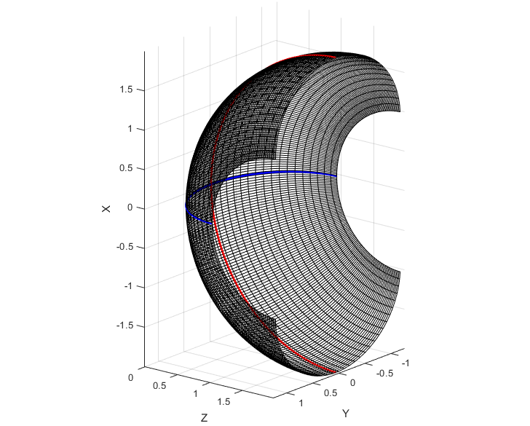
$$R_{y}$$
$$r_{x}$$
Figure 1: Toroidal Surface with the circle radius $r_{x}$ and the radius of rotation $R_{y}$

Toroidal Surface Description
If the radii in the range of $0≤r_{x}≤R_{y}$, the toroidal surface in three-dimensional space without a conic constant can be described with
$$z=R_{y}-\sqrt{{\left(R_{y}-r_{x}+\sqrt{r_{x}^{2}-y^{2}}\right)}^{2}-x^{2}}$$
as given in [Gross05]. In order to derive the three-dimensional formulation with a conic constant, one can first regard the curve within the y-z plane ($x=0$) it yields

$$z=R_{y}-\left(R_{y}-r_{x}+\sqrt{r_{x}^{2}-y^{2}}\right)=r_{x}-\sqrt{r_{x}^{2}-y^{2}}$$
The last formulation is similar to the description of a spherical surface $z_{Sphere} =R_{i}-\sqrt{R_{i}^{2}-ρ^{2}}$. Furthermore, the introduction of the conic constant leads to
$$z_{conicSphere}=\frac{1}{1+κ}\left(R_{i}-\sqrt{R_{i}^{2}-\left(1+κ\right)ρ^{2}}\right)=\frac{ρ^{2}}{R_{i}+\sqrt{R_{i}^{2}-\left(1+κ\right)ρ^{2}}}=\frac{\frac{1}{R_{i}}ρ^{2}}{1+\sqrt{1-\left(1+κ\right){\frac{1}{R_{i}^{2}}ρ}^{2}}}$$
as derived in [Stoerkle18]. Hereby, $ρ$ is the radial coordinate and a binominal expansion is used for the arrangement. The last result has the same structure as the first term in equation (1). Thus, the formulation of the conic toroidal surface results in analogy
$$z=R_{y}-\sqrt{{\left(R_{y}+\frac{1}{1+κ}\left(-r_{x}+\sqrt{r_{x}^{2}-\left(1+κ\right)y^{2}}\right)\right)}^{2}-x^{2}}.$$
This can be generalized to values of $r_{x}∈R$and $R_{y}∈R$ with
$$z=R_{y}-sign\left(r_{x}\right)\sqrt{{\left(R_{y}+\frac{1}{1+κ}\left(\sqrt{r_{x}^{2}-\left(1+κ\right)y^{2}}-r_{x}\right)\right)}^{2}-x^{2}} ,$$  $$if \left|R_{y}\right|≥\left|\frac{r_{x}}{1+κ}\right| and r_{x}≥0 , or \left|R_{y}\right|≤\left|\frac{r_{x}}{1+κ}\right| and r_{x}≤0$$ | (2)
and
$$z=R_{y}-sign\left(r_{x}\right)\sqrt{{\left(R_{y}+\frac{1}{1+κ}\left(-\sqrt{r_{x}^{2}-\left(1+κ\right)y^{2}}-r_{x}\right)\right)}^{2}-x^{2}}$$  $$if \left|R_{y}\right|<\left|\frac{r_{x}}{1+κ}\right| and r_{x}>0 , or \left|R_{y}\right|>\left|\frac{r_{x}}{1+κ}\right| and r_{x}<0 .$$ | (3)

In order to keep the vertex at the origin, i.e. $z\left(0,0\right)=0$, a constant $z$-shift must be applied. This can be formulated for the following cases,

If $R_{y}≥\frac{r_{x}}{1+κ}$
If $R_{y}r_{x}≥0$
$$z_{corr}=z$$ | (4)
If $R_{y}r_{x}<0$
$$z_{corr}=z-2R$$ | (5)
If $R_{y}<\frac{r_{x}}{1+κ}$
If $R_{y}r_{x}≥0$
$$z_{corr}=z+2\left(\frac{r_{x}}{1+κ}-R\right)$$ | (6)
If $R_{y}r_{x}<0$
$$z_{corr}=z+2\left(\frac{r_{x}}{1+κ}-R\right)-2R$$ | (7)

Range of x & y for Solutions at Real Numbers
In order to avoid complex results for $z$, the range of the $x$- and $y$-coordinates can be limited. Therefore, the terms under the square roots of to equation (2) are considered. For the term within the inner square root it results
$$r_{x}^{2}-\left(1+κ\right)y^{2}≥0$$
$$\frac{r_{x}^{2}}{\left(1+κ\right)}≥y^{2}$$
$$-\frac{\left|r_{x}\right|}{\sqrt{1+κ}}≤y≤\frac{\left|r_{x}\right|}{\sqrt{1+κ}}$$ | (8)
If $R_{y}≠0$, the outer square root results with real values for
$${\left(R_{y}+\frac{1}{1+κ}\left(\sqrt{r_{x}^{2}-\left(1+κ\right)y^{2}}-r_{x}\right)\right)}^{2}≥x^{2}$$
$$\left|R_{y}+\frac{1}{1+κ}\left(\sqrt{r_{x}^{2}-\left(1+κ\right)y^{2}}-r_{x}\right)\right|≥\left|x\right|$$
A more conservative estimation leads to
$$\left|\left|R_{y}\right|+\frac{1}{1+κ}\left(\sqrt{r_{x}^{2}-\left(1+κ\right)y^{2}}-\left|r_{x}\right|\right)\right|≥\left|x\right|.$$

Normal Vector of Toroidal Surface
The surface description given by equation (2) can also be interpreted as a zero-isoplane at the potential $V(x,y,z)$ , which is also called implicit surface representation
$$V\left(x,y,z\right)=R_{y}-sign\left(r_{x}\right)\sqrt{{\left(R_{y}+\frac{1}{1+κ}\left(\sqrt{r_{x}^{2}-\left(1+κ\right)y^{2}}-r_{x}\right)\right)}^{2}-x^{2}}-z=0$$  $$if \left|R_{y}\right|≥\left|\frac{r_{x}}{1+κ}\right| and r_{x}≥0 , or \left|R_{y}\right|≤\left|\frac{r_{x}}{1+κ}\right| and r_{x}≤0 .$$ | (9)
Thereby, the gradient is equal to the direction $n_{i}$ of the unit vector, which is orthogonal
to the surface.
$$n=grad\left(V\left(x,y,z\right)\right)={\left[\begin{matrix}\frac{∂V}{∂x} & \frac{∂V}{∂y} & \frac{∂V}{∂z}\end{matrix} \right]}^{T}$$
At first, the partial derivative in the $x$-direction leads to
$$\frac{∂V}{∂x}=-\frac{1}{2}sign\left(r_{x}\right){\left({\left(R_{y}+\frac{1}{1+κ}\left(\sqrt{r_{x}^{2}-\left(1+κ\right)y^{2}}-r_{x}\right)\right)}^{2}-x^{2}\right)}^{-\frac{1}{2}}\left(-2x\right)$$
$$=sign\left(r_{x}\right)\frac{x}{\sqrt{{\left(R_{y}+\frac{1}{1+κ}\left(\sqrt{r_{x}^{2}-\left(1+κ\right)y^{2}}-r_{x}\right)\right)}^{2}-x^{2}}} =z_{x} .$$

Second, the partial derivative in the $y$-direction leads to
$$\frac{∂V}{∂y}=-\frac{1}{2}sign\left(r_{x}\right){\left(\underset{u\left(x,y\right)}{\underbrace{{\left(R_{y}+\frac{1}{1+κ}\left(\sqrt{r_{x}^{2}-\left(1+κ\right)y^{2}}-r_{x}\right)\right)}^{2}-x^{2}}}\right)}^{-\frac{1}{2}}\frac{∂u_{1}\left(x,y\right)}{∂y} ,$$
where
$$\frac{∂u_{1}\left(x,y\right)}{∂y}=2\left(R_{y}+\frac{1}{1+κ}{\left(r_{x}^{2}-\left(1+κ\right)y^{2}\right)}^{\frac{1}{2}}-\frac{r_{x}}{1+κ}\right)\frac{∂u_{2}\left(x,y\right)}{∂y}$$
and where
$$\frac{∂u_{2}\left(x,y\right)}{∂y}=\frac{1}{2(1+κ)}{\left(r_{x}^{2}-\left(1+κ\right)y^{2}\right)}^{-\frac{1}{2}} (-2(1+κ)y)$$
As a consequence, it follows
$$\frac{∂V}{∂y}=-\frac{1}{2}sign\left(r_{x}\right){\left(\underset{u\left(x,y\right)}{\underbrace{{\left(R_{y}+\frac{1}{1+κ}\left(\sqrt{r_{x}^{2}-\left(1+κ\right)y^{2}}-r_{x}\right)\right)}^{2}-x^{2}}}\right)}^{-\frac{1}{2}} …$$
$$2\left(R_{y}+\frac{1}{1+κ}{\left(r_{x}^{2}-\left(1+κ\right)y^{2}\right)}^{\frac{1}{2}}-\frac{r_{x}}{1+κ}\right)\frac{1}{2(1+κ)}{\left(r_{x}^{2}-\left(1+κ\right)y^{2}\right)}^{-\frac{1}{2}} (-2(1+κ)y)$$
$$=sign\left(r_{x}\right)\frac{y\left(R_{y}+\frac{1}{1+κ}\left(\sqrt{r_{x}^{2}-\left(1+κ\right)y^{2}}-r_{x}\right)\right)}{\sqrt{r_{x}^{2}-\left(1+κ\right)y^{2}} \sqrt{{\left(R_{y}+\frac{1}{1+κ}\left(\sqrt{r_{x}^{2}-\left(1+κ\right)y^{2}}-r_{x}\right)\right)}^{2}-x^{2}} } =z_{y}$$
Third, the partial derivative in the $y$-direction results with
$$\frac{∂V}{∂z}=-1$$

In contrast, the partial derivatives for the cases
$$if \left|R_{y}\right|<\left|\frac{r_{x}}{1+κ}\right| and r_{x}>0 , or \left|R_{y}\right|>\left|\frac{r_{x}}{1+κ}\right| and r_{x}<0$$
results with
$$\frac{∂V}{∂x}=sign\left(r_{x}\right)\frac{x}{\sqrt{{\left(R_{y}+\frac{1}{1+κ}\left(-\sqrt{r_{x}^{2}-\left(1+κ\right)y^{2}}-r_{x}\right)\right)}^{2}-x^{2}}} =z_{x} .$$

$$\frac{∂V}{∂y}=sign\left(r_{x}\right)\frac{y\left(R_{y}+\frac{1}{1+κ}\left(-\sqrt{r_{x}^{2}-\left(1+κ\right)y^{2}}-r_{x}\right)\right)}{-\sqrt{r_{x}^{2}-\left(1+κ\right)y^{2}} \sqrt{{\left(R_{y}+\frac{1}{1+κ}\left(-\sqrt{r_{x}^{2}-\left(1+κ\right)y^{2}}-r_{x}\right)\right)}^{2}-x^{2}} } =z_{y}$$

Finally, the normal unit vector results with
$$\tilde{n}=\frac{1}{\sqrt{1+z_{x}^{2}+z_{y}^{2}}}\left[\begin{matrix}{-z}_{x} \\ -z_{y} \\ 1\end{matrix}\right] .$$

Intersection of a Ray and a Torus
The intersection of a ray with a surface can be defined by the line
$$r_{i}=r_{i-1}+a_{i}d_{i-1}=\left[\begin{matrix}r_{i-1,x} \\ r_{i-1,y} \\ r_{i-1,z}\end{matrix}\right]+a_{i}\left[\begin{matrix}d_{i-1,x} \\ d_{i-1,y} \\ d_{i-1,z}\end{matrix}\right],$$ | (10)
which starts at the former intersection point (or starting point) $r_{i-1}$,by the ray direction $d_{i-1}$and the by distance $a_{i}$ between the intersection points. During the ray tracing, this unknown distance $a_{i}$ must be computed.
The toroidal surface according to equation (2) can be rearranged to
$${\left(z-R_{y}\right)}^{2}={\left(R_{y}+\frac{1}{1+κ}\left(\sqrt{r_{x}^{2}-\left(1+κ\right)y^{2}}-r_{x}\right)\right)}^{2}-x^{2}$$
and the line equation (10) can be insert, which leads to
$${\left(r_{i-1,z}+a_{i}d_{i-1,z}-R_{y}\right)}^{2}={\left(R_{y}+\frac{1}{1+κ}\left(\sqrt{r_{x}^{2}-\left(1+κ\right){(r_{i-1,y}+a_{i}d_{i-1,y})}^{2}}-r_{x}\right)\right)}^{2}-{(r_{i-1,x}+a_{i}d_{i-1,x})}^{2}$$

$${\left(r_{i-1,z}-R_{y}+a_{i}d_{i-1,z}\right)}^{2}={\left(R_{y}+\frac{1}{1+κ}\left(\sqrt{r_{x}^{2}-\left(1+κ\right){\left(r_{i-1,y}+a_{i}d_{i-1,y}\right)}^{2}}-r_{x}\right)\right)}^{2}-…$$
$$(r_{i-1,x}^{2}+2a_{i}r_{i-1,x}d_{i-1,x}+a_{i}^{2}d_{i-1,x}^{2})$$

$$\left({\left(r_{i-1,z}-R_{y}\right)}^{2}+2a_{i}\left(r_{i-1,z}-R_{y}\right)d_{i-1,z}+a_{i}^{2}d_{i-1,z}^{2}\right)=R_{y}^{2}+2R_{y}\frac{1}{1+κ}\left(\sqrt{r_{x}^{2}-\left(1+κ\right){\left(r_{i-1,y}+a_{i}d_{i-1,y}\right)}^{2}}-r_{x}\right)+\frac{1}{{\left(1+κ\right)}^{2}}{\left(\sqrt{r_{x}^{2}-\left(1+κ\right){\left(r_{i-1,y}+a_{i}d_{i-1,y}\right)}^{2}}-r_{x}\right)}^{2}-(r_{i-1,x}^{2}+2a_{i}r_{i-1,x}d_{i-1,x}+a_{i}^{2}d_{i-1,x}^{2})$$

$$\left({\left(r_{i-1,z}-R_{y}\right)}^{2}+2a_{i}\left(r_{i-1,z}-R_{y}\right)d_{i-1,z}+a_{i}^{2}d_{i-1,z}^{2}\right)+(r_{i-1,x}^{2}+2a_{i}r_{i-1,x}d_{i-1,x}+a_{i}^{2}d_{i-1,x}^{2})=R_{y}^{2}-2R_{y}\frac{1}{1+κ}r_{x}+2R_{y}\frac{1}{1+κ}\sqrt{r_{x}^{2}-\left(1+κ\right){\left(r_{i-1,y}+a_{i}d_{i-1,y}\right)}^{2}}+\frac{1}{{\left(1+κ\right)}^{2}}\left(r_{x}^{2}-\left(1+κ\right){\left(r_{i-1,y}+a_{i}d_{i-1,y}\right)}^{2}-2r_{x}\sqrt{r_{x}^{2}-\left(1+κ\right){\left(r_{i-1,y}+a_{i}d_{i-1,y}\right)}^{2}}+r_{x}^{2}\right)$$

$$\left(r_{i-1,z}^{2}-2r_{i-1,z}R_{y}+R_{y}^{2}+2a_{i}\left(r_{i-1,z}-R_{y}\right)d_{i-1,z}+a_{i}^{2}d_{i-1,z}^{2}\right)+\left(r_{i-1,x}^{2}+2a_{i}r_{i-1,x}d_{i-1,x}+a_{i}^{2}d_{i-1,x}^{2}\right)-R_{y}^{2}+2R_{y}\frac{1}{1+κ}r_{x}-\frac{1}{{\left(1+κ\right)}^{2}}\left(r_{x}^{2}-\left(1+κ\right){\left(r_{i-1,y}+a_{i}d_{i-1,y}\right)}^{2}+r_{x}^{2}\right)=2\frac{1}{1+κ}\left(R_{y}-\frac{r_{x}}{1+κ}\right)\sqrt{r_{x}^{2}-\left(1+κ\right){\left(r_{i-1,y}+a_{i}d_{i-1,y}\right)}^{2}}$$

$$a_{i}^{2}d_{i-1,x}^{2}+a_{i}^{2}d_{i-1,z}^{2}+2a_{i}r_{i-1,x}d_{i-1,x}+2a_{i}\left(r_{i-1,z}-R_{y}\right)d_{i-1,z}+r_{i-1,x}^{2}+r_{i-1,z}^{2}-2r_{i-1,z}R_{y}+R_{y}^{2}-R_{y}^{2}+2R_{y}\frac{1}{1+κ}r_{x}-\frac{1}{{\left(1+κ\right)}^{2}}\left(2r_{x}^{2}-\left(1+κ\right)\left(r_{i-1,y}^{2}+2a_{i}r_{i-1,y}d_{i-1,y}+a_{i}^{2}d_{i-1,y}^{2}\right)\right)=2\frac{1}{1+κ}\left(R_{y}-\frac{r_{x}}{1+κ}\right)\sqrt{r_{x}^{2}-\left(1+κ\right)\left(r_{i-1,y}+2a_{i}r_{i-1,y}d_{i-1,y}+a_{i}^{2}d_{i-1,y}^{2}\right)}$$

$$a_{i}^{2}d_{i-1,x}^{2}+a_{i}^{2}d_{i-1,z}^{2}+2a_{i}r_{i-1,x}d_{i-1,x}+2a_{i}\left(r_{i-1,z}-R_{y}\right)d_{i-1,z}+r_{i-1,x}^{2}+r_{i-1,z}^{2}-2r_{i-1,z}R_{y}+2R_{y}\frac{1}{1+κ}r_{x}-\frac{2r_{x}^{2}}{{\left(1+κ\right)}^{2}}+\frac{r_{i-1,y}^{2}}{\left(1+κ\right)}+2a_{i}\frac{r_{i-1,y}d_{i-1,y}}{\left(1+κ\right)}+a_{i}^{2}\frac{d_{i-1,y}^{2}}{\left(1+κ\right)}=2\frac{1}{1+κ}\left(R_{y}-\frac{r_{x}}{1+κ}\right)\sqrt{r_{x}^{2}-\left(1+κ\right)\left(r_{i-1,y}+2a_{i}r_{i-1,y}d_{i-1,y}+a_{i}^{2}d_{i-1,y}^{2}\right)}$$

$$a_{i}^{2}d_{i-1,x}^{2}+a_{i}^{2}\frac{d_{i-1,y}^{2}}{\left(1+κ\right)}+a_{i}^{2}d_{i-1,z}^{2}+2a_{i}r_{i-1,x}d_{i-1,x}+2a_{i}\frac{r_{i-1,y}d_{i-1,y}}{\left(1+κ\right)}+2a_{i}\left(r_{i-1,z}-R_{y}\right)d_{i-1,z}+r_{i-1,x}^{2}+\frac{r_{i-1,y}^{2}}{\left(1+κ\right)}+r_{i-1,z}^{2}-2r_{i-1,z}R_{y}+2R_{y}\frac{1}{1+κ}r_{x}-\frac{2r_{x}^{2}}{{\left(1+κ\right)}^{2}}=2\frac{1}{1+κ}\left(R_{y}-\frac{r_{x}}{1+κ}\right)\sqrt{r_{x}^{2}-\left(1+κ\right)\left(r_{i-1,y}+2a_{i}r_{i-1,y}d_{i-1,y}+a_{i}^{2}d_{i-1,y}^{2}\right)}$$

$$a_{i}^{2}\frac{\left(1+κ\right)}{2} \left(d_{i-1,x}^{2}+\frac{d_{i-1,y}^{2}}{\left(1+κ\right)}+d_{i-1,z}^{2}\right)+a_{i}\left(1+κ\right)\left(r_{i-1,x}d_{i-1,x}+\frac{r_{i-1,y}d_{i-1,y}}{\left(1+κ\right)}+\left(r_{i-1,z}-R_{y}\right)d_{i-1,z}\right)+\frac{\left(1+κ\right)}{2}\left(r_{i-1,x}^{2}+\frac{r_{i-1,y}^{2}}{\left(1+κ\right)}+r_{i-1,z}^{2}\right)-\left(1+κ\right)\left(r_{i-1,z}R_{y}+R_{y}\frac{r_{x}}{1+κ}-\frac{r_{x}^{2}}{{\left(1+κ\right)}^{2}}\right)=\left(R_{y}-\frac{r_{x}}{1+κ}\right)\sqrt{r_{x}^{2}-\left(1+κ\right)\left(r_{i-1,y}+2a_{i}r_{i-1,y}d_{i-1,y}+a_{i}^{2}d_{i-1,y}^{2}\right)}$$

with $ξ={\left(R_{y}-\frac{r_{x}}{1+κ}\right)}^{-1}$ it follows
$$a_{i}^{2}\frac{\left(1+κ\right)ξ}{2}\left(d_{i-1,x}^{2}+\frac{d_{i-1,y}^{2}}{\left(1+κ\right)}+d_{i-1,z}^{2}\right)+a_{i}\left(1+κ\right)ξ\left(r_{i-1,x}d_{i-1,x}+\frac{r_{i-1,y}d_{i-1,y}}{\left(1+κ\right)}+\left(r_{i-1,z}-R_{y}\right)d_{i-1,z}\right)+\frac{\left(1+κ\right)ξ}{2}\left(r_{i-1,x}^{2}+\frac{r_{i-1,y}^{2}}{\left(1+κ\right)}+r_{i-1,z}^{2}\right)-\left(1+κ\right)ξ\left(r_{i-1,z}R_{y}+R_{y}\frac{r_{x}}{1+κ}-\frac{r_{x}^{2}}{{\left(1+κ\right)}^{2}}\right)=\sqrt{r_{x}^{2}-\left(1+κ\right)\left(r_{i-1,y}+2a_{i}r_{i-1,y}d_{i-1,y}+a_{i}^{2}d_{i-1,y}^{2}\right)}$$

$${\left[a_{i}^{2}\frac{\left(1+κ\right)ξ}{2}\left(d_{i-1,x}^{2}+\frac{d_{i-1,y}^{2}}{\left(1+κ\right)}+d_{i-1,z}^{2}\right)+a_{i}\left(1+κ\right)ξ\left(r_{i-1,x}d_{i-1,x}+\frac{r_{i-1,y}d_{i-1,y}}{\left(1+κ\right)}+\left(r_{i-1,z}-R_{y}\right)d_{i-1,z}\right)+\frac{\left(1+κ\right)ξ}{2}\left(r_{i-1,x}^{2}+\frac{r_{i-1,y}^{2}}{\left(1+κ\right)}+r_{i-1,z}^{2}\right)-\left(1+κ\right)ξ\left(r_{i-1,z}R_{y}+R_{y}\frac{r_{x}}{1+κ}-\frac{r_{x}^{2}}{{\left(1+κ\right)}^{2}}\right)\right]}^{2}=r_{x}^{2}-\left(1+κ\right)\left(r_{i-1,y}+2a_{i}r_{i-1,y}d_{i-1,y}+a_{i}^{2}d_{i-1,y}^{2}\right)$$
…

- This leads to a cubic equation, where the solution can be computed by appropriate algorithms, see also the Attachement. However, it is probably simpler to compute the Ray-ConicTorus intersetions with an iterative zero searching algorithm, e.g. the Newton-Raphson Approach.

Special Case: Cylinder Lens
The toroidal surface according to equations (2) and (3) can also be used to describe a cylinder surface with the long axis in the direction of $x$. Therefore, the radius of rotation must tend to infinity, $R_{y}→∞,$. As an alternative, once can set
$$x=0 and{ R}_{y}=0,$$
which leads to
$$z=-sign\left(r_{x}\right)\frac{1}{1+κ}\left(\sqrt{r_{x}^{2}-\left(1+κ\right)y^{2}}-sign\left(r_{x}\right)r_{x}\right) .$$
For the normal unity vector, it yields
$$\frac{∂V}{∂x}=0=z_{x} ,$$
$$\frac{∂V}{∂y}=sign\left(r_{x}\right)\frac{y}{\sqrt{r_{x}^{2}-\left(1+κ\right)y^{2}} } =z_{y}.$$

Cylinder-Line Intersection

$$z=-sign\left(r_{x}\right)\frac{1}{1+κ}\left(\sqrt{r_{x}^{2}-\left(1+κ\right)y^{2}}-sign\left(r_{x}\right)r_{x}\right)$$
$$-sign\left(r_{x}\right)\left(1+κ\right)z=\sqrt{r_{x}^{2}-\left(1+κ\right)y^{2}}-sign\left(r_{x}\right)r_{x}$$
For $r_{x}>0$ and if the $y$-values are within the range of equation (8), it results
$$-\left(1+κ\right)z=\sqrt{r_{x}^{2}-\left(1+κ\right)y^{2}}-r_{x}$$

$$({r_{x} -\left(1+κ\right)z)}^{2}=r_{x}^{2}-\left(1+κ\right)y^{2}$$

$$r_{x}^{2}-2\left(1+κ\right)z r_{x}+{\left(1+κ\right)}^{2}z^{2}=r_{x}^{2}-\left(1+κ\right)y^{2}$$

$${{\left(1+κ\right)}^{2}z}^{2}+\left(1+κ\right)y^{2}-2\left(1+κ\right)z r_{x}=0$$

$${\left(1+κ\right)}^{2}{\left(r_{i-1,z}+a_{i}d_{i-1,z}\right)}^{2}+\left(1+κ\right){\left(r_{i-1,y}+a_{i}d_{i-1,y}\right)}^{2}-2\left(1+κ\right)\left(r_{i-1,z}+a_{i}d_{i-1,z}\right) r_{x}=0$$

$${\left(1+κ\right)}^{2}\left(r_{i-1,z}^{2}+2a_{i}r_{i-1,z}d_{i-1,z}+a_{i}^{2}d_{i-1,z}^{2}\right)+\left(1+κ\right)\left(r_{i-1,y}^{2}+2a_{i}r_{i-1,y}d_{i-1,y}+a_{i}^{2}d_{i-1,y}^{2}\right)-2\left(1+κ\right)\left(r_{i-1,z}+a_{i}d_{i-1,z}\right) r_{x}=0$$

$$\left(1+κ\right)\left(r_{i-1,z}^{2}+2a_{i}r_{i-1,z}d_{i-1,z}+a_{i}^{2}d_{i-1,z}^{2}\right)+\left(r_{i-1,y}^{2}+2a_{i}r_{i-1,y}d_{i-1,y}+a_{i}^{2}d_{i-1,y}^{2}\right)-2\left(r_{i-1,z}+a_{i}d_{i-1,z}\right) r_{x}=0$$

$$a_{i}^{2}\left(\left(1+κ\right)d_{i-1,z}^{2}+d_{i-1,y}^{2}\right)+2a_{i}\left(\left(1+κ\right)r_{i-1,z}d_{i-1,z}+r_{i-1,y}d_{i-1,y}- r_{x}d_{i-1,z}\right)+\left(1+κ\right)r_{i-1,z}^{2}+r_{i-1,y}^{2}-2r_{x}r_{i-1,z}=0$$
$⇒$ The solution of this quadratic equation
$$Ha_{i}^{2}+2Fa_{i}-G=0$$
where
$$H=\left(1+κ\right)d_{i-1,z}^{2}+d_{i-1,y}^{2}$$
$$F=\left(1+κ\right)r_{i-1,z}d_{i-1,z}+r_{i-1,y}d_{i-1,y}-r_{x}d_{i-1,z}$$
$$G=-\left(1+κ\right)r_{i-1,z}^{2}-r_{i-1,y}^{2}+2r_{x}r_{i-1,z}$$
is known as
$$⇒a_{i,1,2}=-\frac{F}{H}±\sqrt{\frac{F^{2}}{H^{2}}-\frac{G}{H}}=\frac{\left(±\sqrt{\frac{F^{2}}{H^{2}}-\frac{G}{H}}-\frac{F}{H}\right)\left(±\sqrt{\frac{F^{2}}{H^{2}}-\frac{G}{H}}+\frac{F}{H}\right)}{\left(±\sqrt{\frac{F^{2}}{H^{2}}-\frac{G}{H}}+\frac{F}{H}\right)}=\frac{G}{F±\sqrt{F^{2}+HG}} .$$

In detail it yields
$$⇒ a_{i}=\frac{G}{F-\sqrt{F^{2}+HG}} , for r_{x}>0$$
$$⇒ a_{i}=\frac{G}{F+\sqrt{F^{2}+HG}} , for r_{x}<0$$

Parametrical Toroidal Surface Description
A torus can be defined parametrically by
$$\left[\begin{matrix}x \\ y \\ z\end{matrix}\right]=\left[\begin{matrix}\left(R_{y}-r_{x}+r_{x}\cos{θ}\right)\cos{ϕ} \\ r_{x}\sin{θ} \\ \left(R_{y}-r_{x}+r_{x}\cos{θ}\right)\sin{ϕ}\end{matrix}\right]$$

In case of $κ≠0$ it is proposed to use the implicit description for the $z$-term.
$$\left[\begin{matrix}x \\ y \\ z\end{matrix}\right]=\left[\begin{matrix}\left(R_{y}-r_{x}+r_{x}\cos{θ}\right)\cos{ϕ} \\ \frac{1}{\sqrt{1+κ}}r_{x}\sin{θ} \\ z_{corr}\end{matrix}\right]$$

Practical Example with MATLAB

A related MATLAB implementation can be found here:
https://de.mathworks.com/matlabcentral/answers/95230-how-do-i-plot-a-toroid-in-matlab

Attachement
The following screenshots help to understand the tori equations, which are from [Reithmann2009].

Page 12
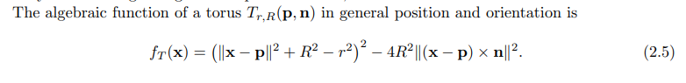
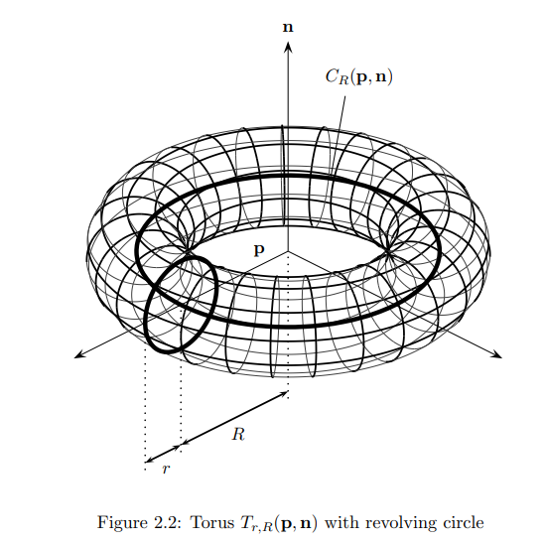

Page 69
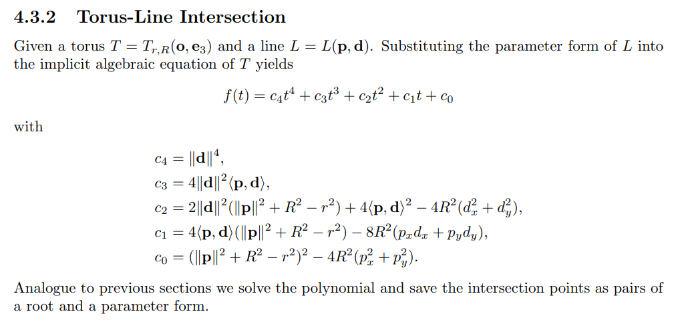
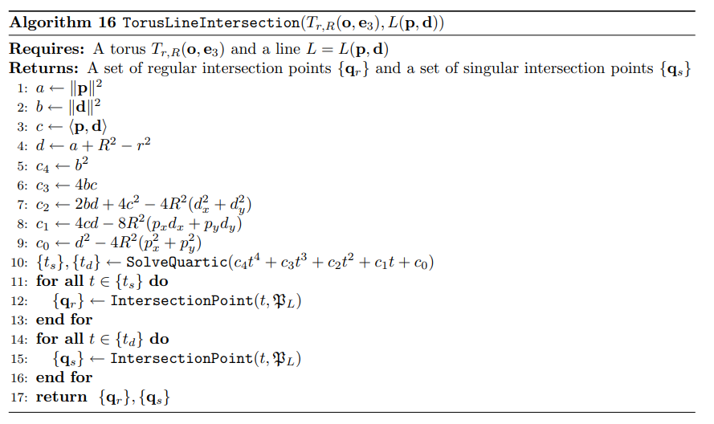

[Zemax11] Zemax: Zemax Optical Design Program - User's Manual. Radiant ZEMAX LLC, 2011.
[Gross05] Gross, H. (Ed.): Handbook of Optical Systems Vol. 1 - Fundamentals of Technical Optics. Weinheim: Wiley-VCH Verlag, 2005. (see also PPT IAP Jena)
[Stoerkle18] Störkle, J.: Dynamic Simulation and Control of Optical Systems. No. 58 in Dissertation, Schriften aus dem Institut für Technische und Numerische Mechanik der Universität Stuttgart. Shaker Verlag, Aachen (2018). Shaker Verlag
[Reithmann2009] Reithmann, T.: Topologically correct Intersection Curves of Tori and Natural Quadrics, Dissertation der Johannes Gutenberg-Universität, FB 08: Physik, Mathematik und Informatik, 2009. (See also https://d-nb.info/995451133/34)

